Introduction

As ash trees in the canopy die, the space previously occupied becomes available, leaving a gap. Multiple processes might occur in these gaps, including increases in growth rate of neighboring non-ash canopy trees due to competitive release (Flower et al. 2013). For example, non-ash canopy trees in upland forests in Ohio increased their growth rates after canopy ash mortality, thus compensating for the loss of ash tree cover (Hoven et al. 2020). However, different processes might be occurring in hydric forests. Most significantly, hydric forests experience waterlogged soils for part of the year, creating hypoxic or anoxic conditions that stress tree roots (Kreuzwieser and Rennenberg 2014). Few tree species can survive in seasonally inundated soils, and even fewer in permanently flooded soils (Sampson 1930, Golet et al. 1993). As canopy ash trees died, the water table may have become elevated due to reduced evapotranspiration (Kolka et al. 2018). With this stressor, it is unclear whether non-ash canopy trees can fully compensate for the loss of ash canopy. Similarly, immature trees in the understory and subcanopy could respond positively to the loss of ash canopy, but would also have to contend with waterlogging stress (Costilow et al. 2017, Davis et al. 2017, Dolan and Kilgore 2018). If the loss of canopy ash causes a long-term reduction in tree basal area in hydric forests, then other wetland types may partially replace the forest, including shrub-dominated swamps, wet meadows dominated by sedges, or marshes with emergent vegetation such as cattail (Kost and O’Connor 2003, Palik et al. 2012). These vegetation changes would change the communities of aquatic invertebrates, amphibians, birds, and mammals (Youngquist et al. 2017, Kolka et al. 2018). Thus, research is needed to determine the future trajectories of swamp forests formerly dominated by ash trees.

Our third objective was to determine, within hydric forests, whether non-ash trees responded to the death of canopy ash by increasing their growth rates. We hypothesized that forests which had greater basal area of ash trees before EAB invasion would have greater increases in non-ash tree basal area following the death of the ash canopy, due to competitive release (Flower et al. 2013). Furthermore, we hypothesized that this pattern would only hold for flood-tolerant tree species (Golet et al. 1993).

Methods

To test whether non-ash trees in hydric transects experienced competitive release following the death of canopy ash trees, we utilized data collected between 2008-2010 in the same transects that we visited in 2024-2025. To test the prediction that the basal area of ash trees before EAB invasion would be positively correlated with the growth of non-ash trees, we used linear models, implemented using the R package ‘stats’ (R Core Team 2024). Our predictor variable was the basal area of all living and dead ash trees ≥ 12.5 cm DBH, measured in 2008-2010. We used this as a proxy for disturbance severity, since almost all (>99%) of ash ≥ 2.5 cm DBH were killed by 2009 in our transects (Klooster et al. 2014). In transects with higher pre-EAB basal area, the mortality of these ash trees would create a larger canopy disturbance. Our response variable was the change in basal area of non-ash canopy trees ≥12.5 cm DBH between 2008-2010 and 2025, a ~16 year interval of time beginning during the peak of ash mortality. The plot center trees of 28 of the 30 hydric plots were not changed between 2008-10 to 2025, and the remaining 2 plot centers were moved < 8 meters to designate new center trees when the previous trees fell (Diane Hartzler, personal communication). Thus, the data represent changes in basal area at the same or very similar locations within the forest stands. In addition to the total change in basal area of all non-ash trees, we also investigated the change in basal area by tree genus.

Results

The tree inventory conducted in 2024-2025 was compared with the one done in 2008-2010 to assess the competitive release hypothesis. Before canopy ash death, the basal area of canopy ash ranged from 1.89 m²/ha to 11.99 m²/ha. We found that this pre-EAB basal area of ash was correlated with increases in basal area of non-ash trees (t= t=2.502, p=0.037, Figure 6). Furthermore, the genus Acer responded most positively to canopy ash mortality (Figure 7).

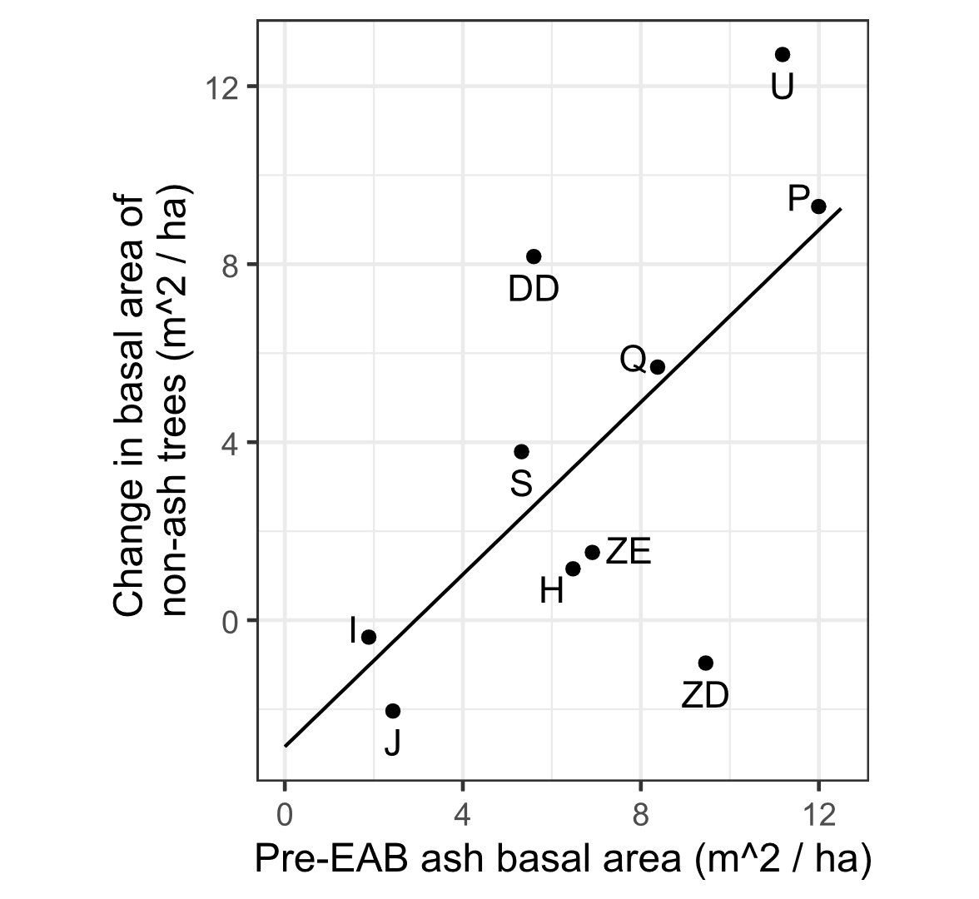
Figure 6. The change in basal area of non-ash trees versus the pre-EAB basal area of ash in the canopy. The x-axis shows the basal area of all living and dead ash ≥ 12.5 cm DBH, as measured during the 2008-2010 inventory. The y-axis shows the change in basal area of non-ash canopy (≥ 12.5 cm DBH) trees between the 2008-2010 inventory and the 2025 inventory (~16 year interval). The linear trendline is a linear model with slope m=0.97 and intercept b=-2.84 m²/ha. The slope differs significantly from 0 (2-sided t-test, t=2.502, p=0.037). Points are labelled with the transect code (Table S1).

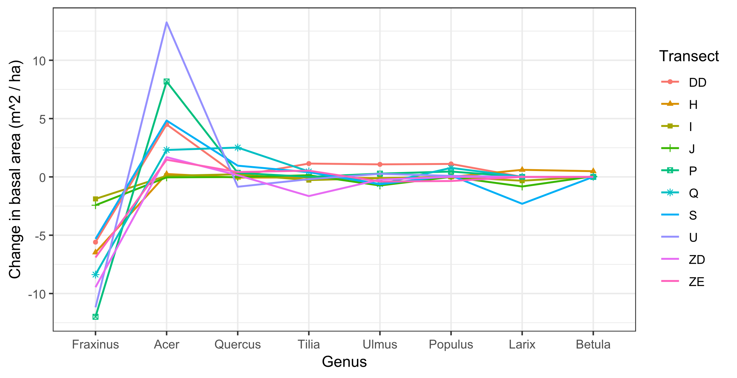
Figure 7. Change in basal area of canopy (≥ 12.5 cm DBH) trees from the 2008-2010 to 2024-2025.

